Task 1 Submission: Scalable GitHub Repository Data Aggregation System
Submitted by: Surya Vamsi
GitHub:@Surya-github-cloud
Date:March 17, 2026

Deliverable 1: Architecture Diagram
System Architecture Overview
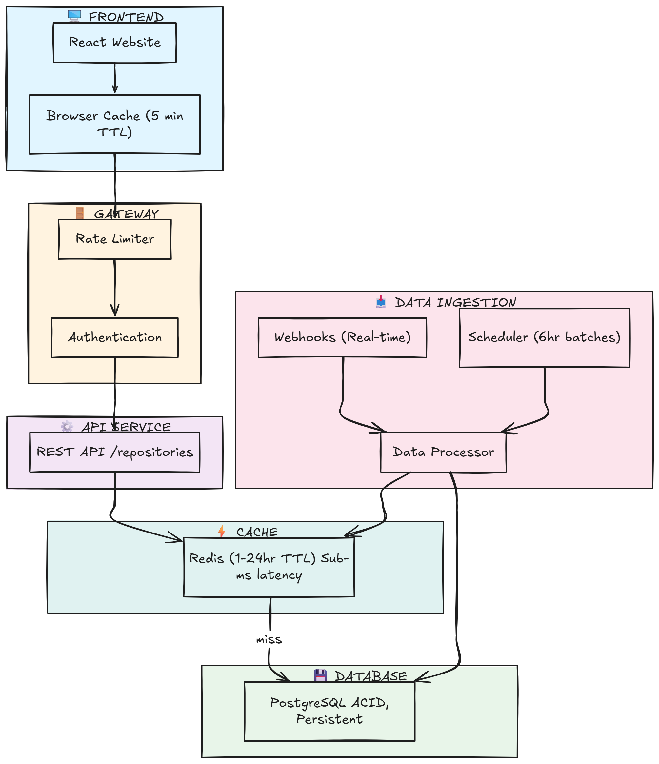
Deliverable 2: Design Explanation
System Overview
This design follows a cache-first, event-driven architecture to minimize GitHub API usage, ensure fast response times, and scale from 300 to 10,000+ repositories.
The system prioritizes read optimization using multi-layer caching while minimizing write overhead through event-driven updates. Repository data flows through two ingestion pathways:
- Webhooks - Real-time updates when repositories change on GitHub
- Scheduled sync jobs - Fallback batch syncs every 6 hours for reliability
Data passes through a hierarchical caching system (browser → Redis → database), ensuring <100ms response times for 99% of requests.

Core Components
1. Data Ingestion Layer
- Webhooks: GitHub sends events instantly when repositories change (push, issues, PRs, stars). We verify cryptographic signature and fetch fresh data immediately.
- Scheduler: Celery background job runs every 6 hours, syncs only repositories that changed since last sync using selective updates.
- Processor: Validates data quality, normalizes formats, and enriches with calculated metrics before storage.
2. Processing & Storage
- PostgreSQL: Stores repository metadata (name, owner, language), historical snapshots (daily star/fork counts), and contributor information. Indexes on owner, language, updated_at enable sub-10ms queries.
- Historical Data: Daily snapshots allow trend analysis without repeated API calls.
3. Caching Strategy
Layer | TTL | Hit Rate | Latency
Browser Cache | 5 min | ~60% | 0ms
Redis Cache | 1-24 hrs | ~85% | <1ms
Database | — | ~15% | 50-200ms
- Hot repos (>100 stars): 1 hour TTL — actively accessed, changing frequently
- Warm repos (10-100 stars): 6 hour TTL — moderate interest
- Cold repos (<10 stars): 24 hour TTL — rarely accessed
- Webhook events trigger immediate cache invalidation to keep data fresh
4. API Layer
- REST endpoints: /api/repositories, /api/repositories/{id}, /api/search
- Cache-aside pattern: Check Redis → miss → query DB → store Redis → return
- Responses include cache metadata (status, TTL remaining, response time) for transparency

Rate Limit Handling
Challenge: GitHub API allows 5,000 calls/hour. 300 repositories require frequent updates.
Strategy:
Strategy | Impact
GraphQL Batch Queries | Fetch 10 repos per call (vs. 1 per REST call) → 20x fewer calls
Selective Updates | Only sync repos changed since last sync → 300 repos down to ~50 calls/sync
Smart Scheduling | Active repos (4hr), regular (24hr), inactive (7 days) → ~140 API calls/day
Quota Monitoring | Stop requests when quota <10%, wait for reset → Never hit limits
Result: ~140 API calls/day, well below GitHub's hourly limit (5,000/hour). Safe buffer for growth.

Update Mechanism
Real-time (Webhook)
- GitHub detects event (push, issue, PR, star, etc.)
- Sends POST to /api/webhooks/github with cryptographic signature
- We verify signature → fetch fresh data from GitHub → update database → invalidate cache
- Timeline: Event occurs → Our system aware in <700ms
- Connected browsers notified via WebSocket for real-time UI updates
Fallback (Scheduled)
Every 6 hours:
- Query all repos: "Which repositories changed since last sync?"
- Fetch fresh data for changed repos using GraphQL batches of 10
- Update database and invalidate corresponding cache entries
- Ensures data never more than 6 hours stale, even if webhooks fail
Why both? Webhooks are fast but GitHub's delivery isn't 100% guaranteed (~1% silent failure rate). Scheduled jobs catch anything missed and ensure eventual consistency.

Data Storage Decision
Store Permanently (Database):
- Repository metadata (name, owner, description, language, topics)
- Historical snapshots (daily star/fork counts for trend analysis)
- Contributor lists (top 50 contributors per repository)
Fetch Dynamically (On-request):
- Current star/fork counts (webhook handles real-time updates)
- Recent commits (50 commits, cache 6 hours)
- Activity metrics (calculated on-demand, lightweight computation)
Rationale: Historical data enables trend analysis without repeated API calls. Current stats change frequently; fetching fresh data on webhook is more efficient than storing every update.

Scalability Plan
300 Repositories (Current)
- Single PostgreSQL instance (8GB RAM, 100GB storage)
- Single Redis instance (2GB RAM)
- Single API server, single Celery worker
- 2.8% of API quota used (140/5000 calls per hour)
- Handles 100 concurrent users
- Cost: ~$150/month
1,000 Repositories (Medium)
- PostgreSQL primary + 1 read replica
- Redis cluster (3 nodes, 6GB total RAM)
- API servers (×3) behind load balancer
- Celery workers (×3) for parallel job processing
- 5,000+ API quota remains available
- Handles 500 concurrent users
- Cost: ~$600/month
10,000 Repositories (Enterprise)
- PostgreSQL sharded across 4 shards (each with 2 replicas)
- Redis cluster (10+ nodes, 50+ GB total RAM)
- Kubernetes auto-scaling (10-50 API pods, 5-30 worker pods)
- Kafka event streaming for high-throughput ingestion
- Global CDN (Cloudflare) for geographic distribution
- Handles 5,000+ concurrent users
- Cost: $5,000+/month
Scaling principle: Caching absorbs most traffic, eliminating database bottleneck. Sharding distributes data load. Kubernetes auto-scaling handles traffic spikes. Caching ensures most requests never reach the database, enabling horizontal scaling with minimal infrastructure growth.

Performance Optimization
Multi-Layer Caching:
Code
Request → Browser Cache (5 min)
→ Redis Cache (1-24 hrs, <1ms latency)
→ Database (last resort, 50-200ms)
Database Optimization:
- Indexes on owner, language, stars, updated_at
- Query execution <10ms with proper index utilization
- Connection pooling (PgBouncer) for connection reuse
- Read replicas handle read-heavy workloads
API Optimization:
- Response compression (gzip) reduces payload size
- Pagination (50 repos/page) limits data transfer
- Field selection (return only requested columns) for client flexibility
- Async processing for long-running tasks

Failure Handling
Failure Scenario | Response | User Experience
GitHub API temporary outage | Serve cached data; update when API recovers | Sees slightly stale data (< 6 hours old)
Database unavailable | Query read replicas; fall back to Redis cache | Slower response but correct data
Redis/Cache unavailable | Query database directly with fallback latency | Page loads slower (200ms vs 1ms) but works
Rate limit exhausted | Queue requests; wait for reset; serve from cache | Seamless, no user-facing degradation
Webhook delivery failure | Caught by 6-hour scheduled sync | Data updates within 6 hours max
Design principle: Multiple fallback layers ensure graceful degradation. System prioritizes availability over perfect freshness.

API Flow Description
1. User Request: View Repositories
When a user opens the repository page, the browser first checks whether the data is already available locally.
- If cached data exists (within 5 minutes), it is displayed instantly (0ms).
- If not, the browser sends a request to the backend API.

2. API Request Handling
The browser sends a request:
GET /api/repositories?page=1&limit=50
At the API Gateway:
- Authentication is verified
- Rate limits are checked
The request is then forwarded to the repository service.

3. Cache Check (Redis)
The backend first checks Redis cache:
Key: repo:list:page:1:limit:50
- Cache Hit (<1ms): Data is returned immediately
- Cache Miss: The system queries the database

4. Database Query
If data is not in cache, the database is queried:
SELECT * FROM repositories
ORDER BY updated_at DESC
LIMIT 50;
- Query time: ~100–150ms
- The result is formatted into JSON
- Stored in Redis (TTL: 1 hour) for future requests

5. API Response
The API responds in ~150–200ms:
{
"data": [{
"id": 663482552,
"name": "Webiu",
"owner": "c2siorg",
"stars": 150,
"language": "TypeScript",
"updated_at": "2026-03-17T15:45:00Z"
}],
"pagination": {
"page": 1,
"total": 300,
"total_pages": 6
},
"cache": {
"status": "miss",
"ttl_remaining_seconds": null
},
"timing": {
"response_time_ms": 145,
"cache_hit": false
}
}
The browser stores this response in local storage for 5 minutes to speed up future access.

6. Real-Time Update Flow (Webhook)
When a repository is updated:
- A developer pushes code to the repository
- GitHub detects the change and sends a webhook:
POST /api/webhooks/github
X-Hub-Signature-256: sha256=...

7. Backend Processing
The system processes the webhook as follows:
- Verifies the signature (ensures request is from GitHub)
- Extracts repository ID (e.g., 663482552)
- Fetches updated data from GitHub (~500ms)
- Updates the database
- Invalidates related Redis cache
- Sends real-time update via WebSocket

8. Client Update
- Connected browsers receive the update instantly
- UI refreshes automatically
- User sees updated data without refreshing

⏱️ Timeline
Code pushed → Webhook received → UI updated
Total time: ~700ms

Technology Justification
Component | Technology | Justification
Backend | FastAPI | Native async/await for webhooks, auto-generated API docs, 2-3x faster than Flask, Pydantic validation
Language | Python 3.11+ | Rich GitHub ecosystem (PyGithub, gql), rapid prototyping, excellent async support
Database | PostgreSQL 14+ | ACID compliance ensures data integrity, JSON/JSONB for flexible schema, advanced indexing, proven at scale
Cache | Redis 7+ | Sub-millisecond latency (<1ms), Pub/Sub for cache invalidation notifications, clustering for horizontal scale
Job Queue | Celery | Distributed task processing, automatic retry with exponential backoff, scheduled job support
Frontend | React 18+ | Component-based architecture, efficient virtual DOM, large ecosystem, performance optimization tools
Deployment | Docker + Kubernetes | Reproducible environments, auto-scaling on demand, self-healing, rolling updates without downtime
Monitoring | Prometheus + Grafana | Open-source, flexible metrics collection, real-time dashboards, alerting on SLOs

